1. Let’s customize Validation Error Response.
2. The following is what we want.
3. 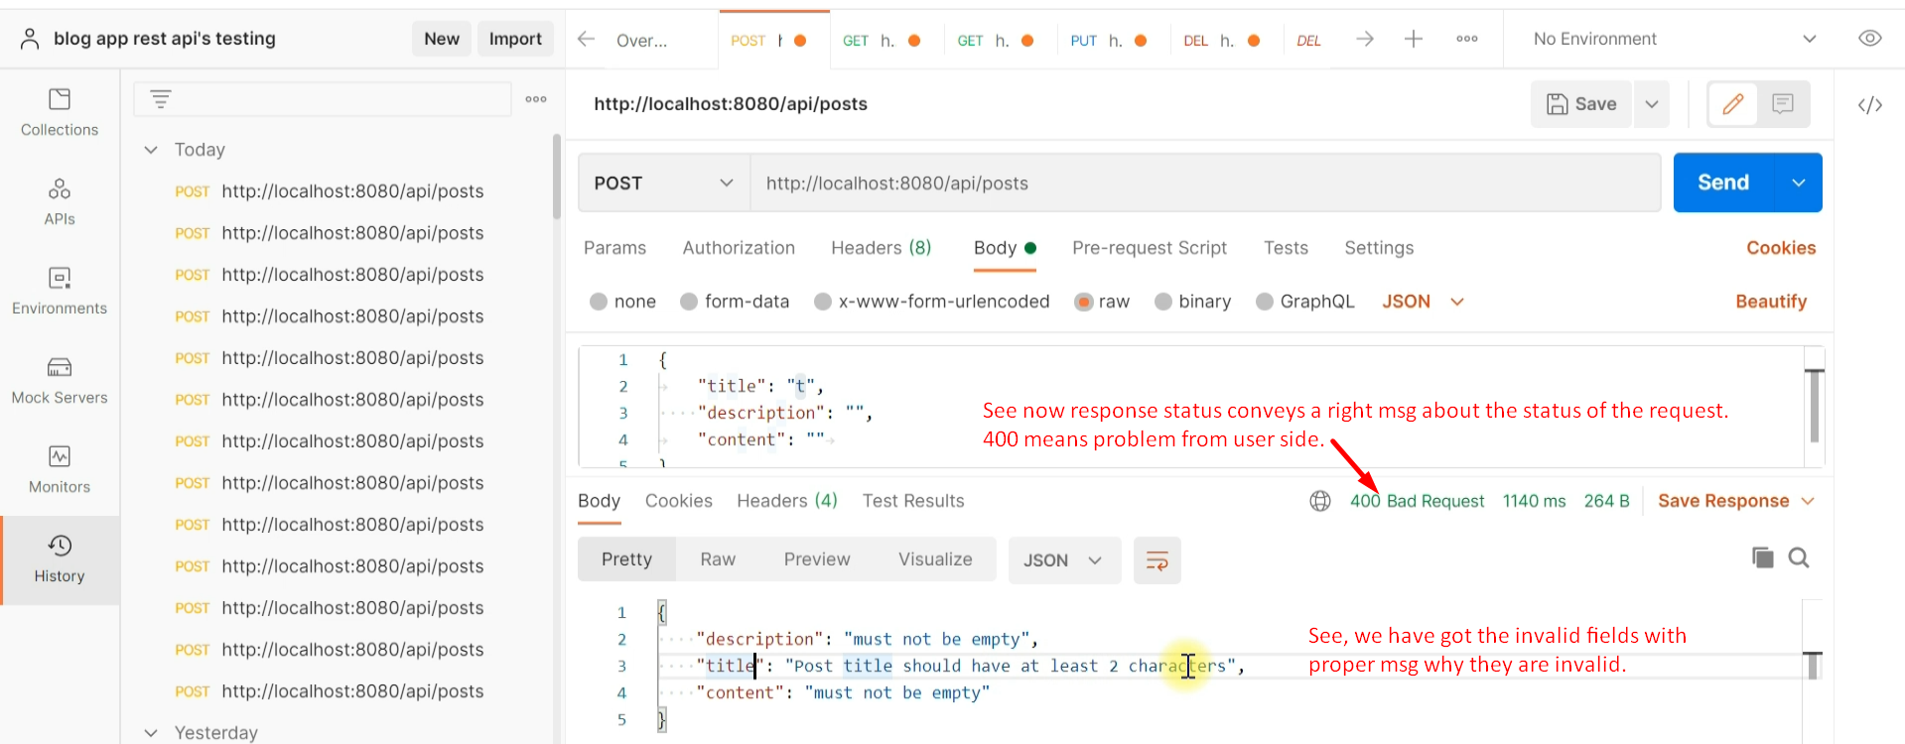
4. There are two approaches to customize validation JSON Error.
   1. Usual way by providing a method annotated with @ExceptionHandler
   2. Overriding a method

First Approach

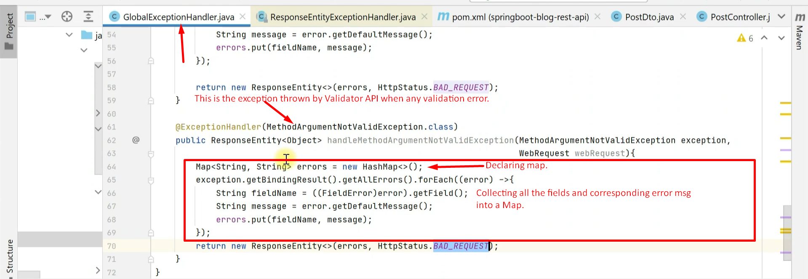

Second Approach

1. 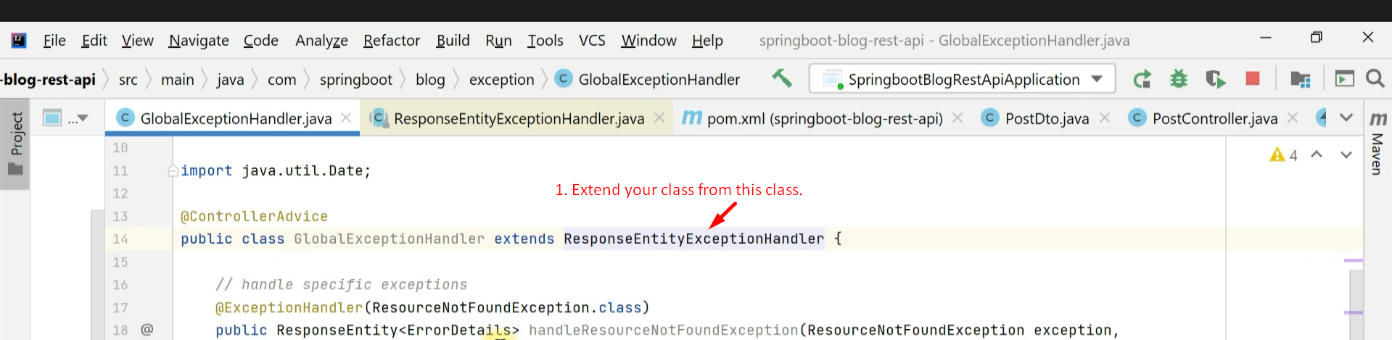
2. 